Erick Cabrera

ITM 311-02

Lab No. 01

August 28, 2016

In this lab we are observing and modifying code for a program that calculates the volume and surface area of a right circular cylinder.

**Volume and Area Calculation Code**

/*

Program to calculate the volume and surface area of a

right circular cylinder.

Programmer: Erick Cabrera, File Name: Cylinder.java

*/

// package for Scanner class objects

import java.util.Scanner;

public class Cylinder

{

public static void main(String args[])

{

// introduce a Scanner class object

Scanner sc = new Scanner(System.in);

// declare and initialize the variables

double height = 0, radius = 0, volume = 0;

String strName = "";

// greet the program user

System.out.println("Welcome to the Volume Program!");

// prompt user for their name

System.out.println("please enter your name");

// read the user name

strName = sc.nextLine();

//display the name back to the user

System.out.println("hello " + strName);

// input: assign values to the variables

System.out.print("Please enter the radius. ");

radius = sc.nextDouble();

System.out.print("Please enter the height. ");

height = sc.nextDouble();

// process: compute the required quantity

volume = 3.1416 * radius * radius * height;

// output: display the output to the user

System.out.print("The volume of the cylinder is: ");

System.out.print(volume);

System.out.println(" cubic length units ");

// dismiss the Scanner class object

sc.close();

}

}

**Volume and Area Output**

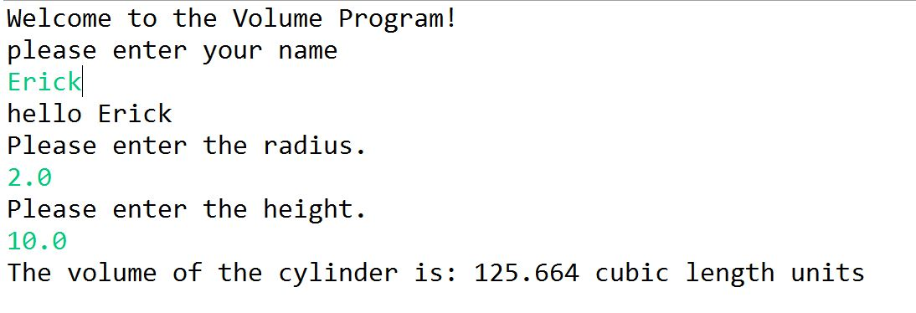

**Modified Volume and Area Calculation Code**

/*

Program to calculate the volume and surface area of a

right circular cylinder.

Programmer: Erick Cabrera, File Name: Cylinder.java

*/

// package for Scanner class objects

import java.util.Scanner;

public class Cylinder

{

public static void main(String args[])

{

// introduce a Scanner class object

Scanner sc = new Scanner(System.in);

// declare and initialize the variables

double height = 0, radius = 0, volume = 0, area = 0;

String strName = "";

// greet the program user

System.out.println("Welcome to the Volume and Area Program!");

// prompt user for their name

System.out.println("please enter your name");

// read the user name

strName = sc.nextLine();

//display the name back to the user

System.out.println("hello " + strName);

// input: assign values to the variables

System.out.print("Please enter the radius. ");

radius = sc.nextDouble();

System.out.print("Please enter the height. ");

height = sc.nextDouble();

// process: compute the required quantity

volume = 3.1416 * radius * radius * height;

area = (2 * 3.1416 * radius * height) + (2 * 3.1416 * radius * radius);

// output: display the output to the user

System.out.print("The volume of the cylinder is: ");

System.out.print(volume);

System.out.println(" cubic length units ");

// output: display the output to the user

System.out.print("The surface area of the cylinder is: ");

System.out.print(area);

System.out.println(" square length units ");

// dismiss the Scanner class object

sc.close();

}

}

**Modified Volume and Area Output**

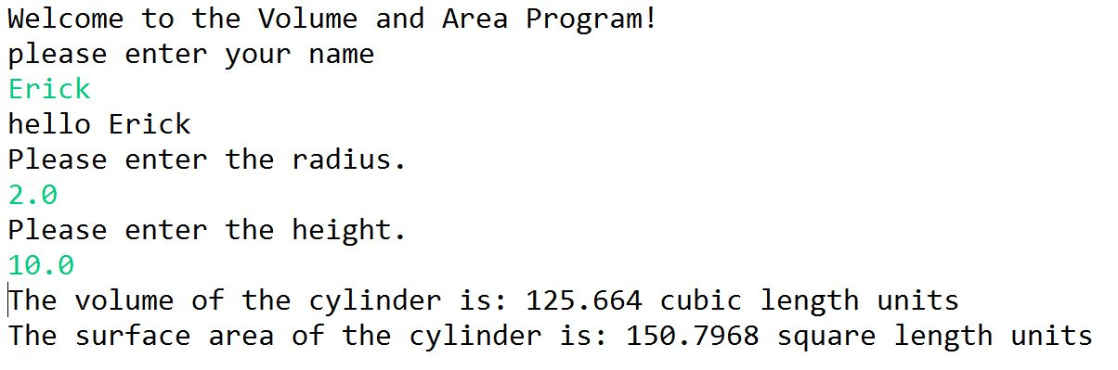

**Excel Sheet**

